U12 Game Rules
Each rule’s number reflects where they are mentioned in Southern Basketball Association’s (SBA) By-Laws. Those without a number are not mentioned in the by-laws, but are game rules enforced by SBA referees.

20.4 - Under 12’s are restricted to 5 seconds in the key.
(The rectangular area below)
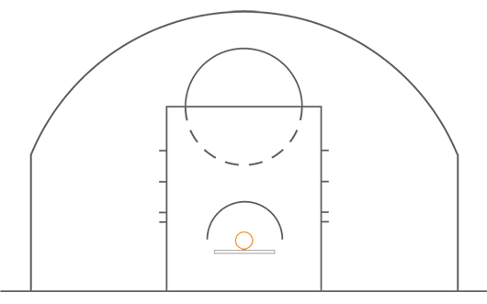

21.2 – Size 6 ball is used in competition for girls and boys under 12’s.

25.1 - The SBA requires all junior teams under 14 and below to play Man-to-Man defence. i.e. requires teams to play at least Quarter Court (3-point line) Man-to-Man defence for the whole game.

25.3 - When the Fall-Back Rule applies, the leading team must fall back to inside the 3-point line when the opposition gains clear possession.
• U12 & U14 20+ Points

25.4 - The coach of the trailing team may elect to not have the Fall-Back Rule apply and can instruct the referees not to apply it.

26.1 - For junior age groups, up to and including Under 12, a player may shoot free throws from the modified free throw line, estimated to be approximately one (1) metre in front of the FIBA free throw line.

34.2 - For junior competition only, the team coach or team manager (if a coach is absent) can approach the referee during the game for clarification of any rulings made by the referee. This must be done at time outs, half time and full time. If they are not satisfied with this outcome or have other concerns, they may approach the Referee Supervisor.

- A player has 5 seconds to in-bound the ball from a throw-in.

- Each team has 8 seconds to move the ball from their back court into the front court.

